**Excel**

**Ms Office Installation step**

1. **Download office customization tool**

**Go To browser and search “Office customization tool”**

**Office suit-> Office LTSC professional plus 2021 – volume license**

**Generate xml file(**configure.xml)

1. **Download office Deployment tool**

**Go to browse and search “office deployment tool”**

1. **Perform installation process**

**Command for setup**

setup /configure configure.xml

What do you mean by data?

In computing, data is information that has been translated into a form that is efficient for movement or processing.

What is the definition of data example?

It includes information like age, time, height, weight, etc. The data is collected by measuring it on required parameters. For example, data on the number of students playing different sports from your class is in quantitative form.

Data is a set of values that represent measurements or observations. Statistics is the study of data, and it can be used to describe, predict, and infer from a dataset.

Excel can store the following type of data:

1. **String**: Textual information, such as labels, names, paragraphs and sentences
2. **Numeric**: We can enter numbers, such as integers, real values and long values.
3. **Formula**: We can enter Formulas in Excel to perform verity of calculations using Excel Objects and Data.
4. **Time & Date**: Excel can handle the different formats of the Time and Data Values including Region Settings.
5. **Currency**: To store the values in the format of global currencies.
6. **Chart**: We can prepare Charts and store the graphs to represent the data in graphical format.
7. **Image**: We insert Images, Pictures, Icons in Excel and store in the Workbooks.
8. **Table**: We can save the data in List Objects and Pivot Tables.
9. **Format**: Verity of the Formats, themes and Styles can be created and Saved in Excel.

Following are most frequent data processing Task.

* **Entry**: We can enter verity of formats of the data in Excel. Numerous tool available for data entry operations in Excel. For example, Ranges, User forms, Formulas.
* **Calculations**: We can perform wide range of calculations using Built-in Excel Functions.
* **Sort**: Very easy to use tools available in Excel for sorting the data in ascending and descending order.
* **Filter**: Filter tools provides more convenient and easy way to filter the data range and tables, including wildcards expressions.
* **Group & Consolidate**: We can group the data by row, column and consolidate to suit our needs and further analysis.
* **Format & Transpose**: Data Formatting and Transpose is easy to perform in Excel using built-in tools.
* **Validate**: Ready to use Data Validation tool provides to restrict the data based on your requirement.
* **Analyse**: We can analyse the Data in Excel using wide range of Math and Statistical function. You can install Analysis Tool Pack add-in for advanced analysis.
* **Present**: Rich and easy to use Chart tools allows you to present the data in Graphical representation.
* What is a Cell?
* A cell in Excel is defined as the intersection of rows and columns. It is present in the form of a rectangular shape. The combination of rows and columns forms a table.
* 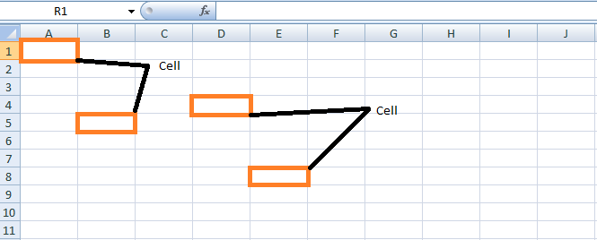
* Cell Address in Excel
* As the name suggests, cell address is the name by which the Cell is addressed. For example, A1 indicates the Cell in the first Row and column.
* 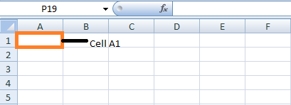
* Features of MS Excel
* The various features of MS Excel are as follows:
* The several features in MS Excel format and edit the data based on the requirement.
* 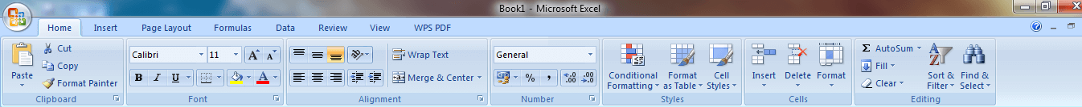
* ADVERTISEMENT
* **Home:** The Home option consists of tabs such as Clipboard, Font, Alignment, Number, Styles, Cells, and Editing.
* **Insert:** The Insert tab consists of Tables, Illustrations, Charts, Links, and Text.
* **Page Layout:** Themes, Page Setup, Page Background, Paragraph, and Arrange.
* **Formulas:** The Formulas consist of Function Library, Defined Names, Formula Auditing and Calculation
* **Data:** The Data consists of Get External Data, Connections, Sort &Filter, Data Tools, and Outline.
* Excel Shortcut Keys
* The shortcut keys present in Excel are as follows:

|  |  |
| --- | --- |
| **Keys** | **Functions** |
| Ctrl+O | Open a Workbook |
| Ctrl+W | Close a Workbook |
| Alt+H | Go to the Home tab |
| Ctrl+S | Save a Workbook |
| Ctrl+C | Copy Selection |
| Ctrl+V | Paste Selection |
| Ctrl+Z | Undo recent action |
| Delete | Remove Cell Contents |
| Alt+H,H | Choose a fill color |
| Ctrl+X | Cut Selection |
| Alt+N | Go to Insert tab |
| Ctrl+B | Apply bold formatting |
| Alt+H, A, C | Center align cell contents |
| Alt+P | Go to the Page Layout tab |
| Alt+A | Go to Data Tab |
| Alt+W | Go to View Tab |
| Shift+F10 or Windows Menu Key | Open the context menu |
| Add borders | Alt+H,B |
| Delete Column | Alt+H, D, C |
| Go to the Formula tab | Alt+M |
| Hide the selected rows | Ctrl+9 |
| Hide the selected columns | Ctrl+0 |

**Get Month or Day Name**

If a cell contains a date, you can extract parts of that date as text, by using the Excel TEXT function.

This screenshot shows the TEXT function, with its argument syntax. There are 2 required arguments:

* **value**: number to convert to text
* **format_text**: text string that defines for the number formatting to use

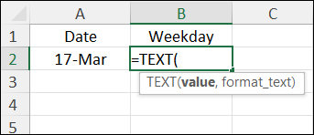

For example, show the month name, or the day of the week name for the date. In this example, the date is in cell A2.

* Month Name (short): **=TEXT(A2,"mmm")**
* Month Name (long): **=TEXT(A2,"mmmm")**
* Weekday Name (short): **=TEXT(A2,"ddd")**
* Weekday Name (long): **=TEXT(A2,"dddd")**

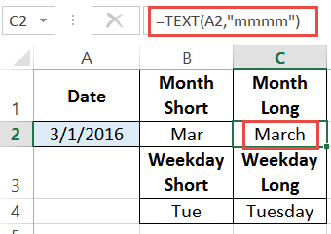

Microsoft Excel is the go-to tool for working with data. There are probably a handful of people who haven’t used Excel, given its immense popularity. Excel is a widely used software application in industries today, built to generate reports and business insights. Excel supports several in-built applications that make it easier to use.

One such feature that allows Excel to stand out is - Excel sheet formulas. Here, we will look into the top 25 Excel formulas that one must know while working on Excel. The topics that we will be covering  in this article are as follows:

* What is Excel Formula?
* Excel Formulas and Functions

## What is Excel Formula?

In Microsoft Excel, a formula is an expression that operates on values in a range of cells. These formulas return a result, even when it is an error. Excel formulas enable you to perform calculations such as addition, subtraction, multiplication, and division. In addition to these, you can find out averages and [calculate percentages in excel](https://www.simplilearn.com/tutorials/excel-tutorial/calculate-percentage-in-excel) for a range of cells, manipulate date and time values, and do a lot more.

#### **Become an AI-powered Business Analyst**

Purdue Post Graduate Program in Business Analysis[EXPLORE NOW](https://www.simplilearn.com/pgp-business-analysis-certification-training-course?source=GhPreviewCTABanner)



## Formulas in Excel: An Overview

* Choose a cell.
* To enter an equal sign, click the cell and type =.
* Enter the address of a cell in the selected cell or select a cell from the list.
* You need to enter an operator.
* Enter the address of the next cell in the selected cell.
* Press Enter.

There is another term that is very familiar to Excel formulas, and that is "[function](https://www.simplilearn.com/tutorials/excel-tutorial/advanced-excel-functions)". The two words, "formulas" and "functions" are sometimes interchangeable. They are closely related, but yet different. A formula begins with an equal sign. Meanwhile, functions are used to perform complex calculations that cannot be done manually. Functions in excel have names that reflect their intended use.

The example below shows how we have used the multiplication formula manually with the ‘*’ operator.

Sample Formula: "=A2*B2"

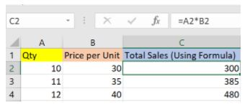

Fig: Microsoft Excel Formula

This example below shows how we have used the function - ‘PRODUCT’ to perform multiplication. As you can see, we didn’t use the mathematical operator here.

Sample Formula: "=PRODUCT(A2,B2)"

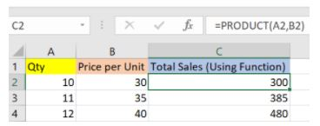

Fig: Microsoft Excel Function

Excel formulas and functions help you perform your tasks efficiently, and it's time-saving. Let's proceed and learn the different types of functions available in Excel and use relevant formulas as and when required.

## Excel Formulas and Functions

There are plenty of Excel formulas and functions depending on what kind of operation you want to perform on the dataset. We will look into the formulas and functions on mathematical operations, character-text functions, data and time, sumif-countif, and few lookup functions.

Let’s now look at the top 25 Excel formulas you must know. In this article, we have categorized 25 Excel formulas based on their operations. Let’s start with the first Excel formula on our list.

### **1. SUM**

The SUM() function, as the name suggests, gives the total of the selected range of cell values. It performs the mathematical operation which is addition. Here’s an example of it below:

Sum "=SUM(C2:C4)"

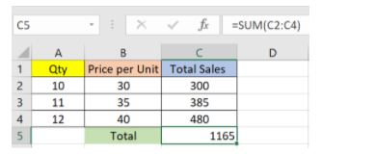

Fig: Sum function in Excel

As you can see above, to find the total amount of sales for every unit, we had to simply type in the function “=SUM(C2:C4)”. This automatically adds up 300, 385, and 480. The result is stored in C5.

### **2. AVERAGE**

The AVERAGE() function focuses on calculating the average of the selected range of cell values. As seen from the below example, to find the avg of the total sales, you have to simply type in:

AVERAGE =AVERAGE(C2, C3, C4)

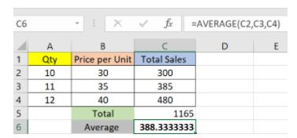

Fig: Average function in Excel

It automatically calculates the average, and you can store the result in your desired location.

### **3. COUNT**

The function [COUNT()](https://www.simplilearn.com/tutorials/excel-tutorial/count-in-excel) counts the total number of cells in a range that contains a number. It does not include the cell, which is blank, and the ones that hold data in any other format apart from numeric.

COUNT =COUNT(C1:C4)

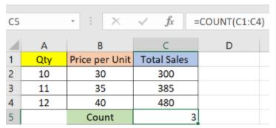

Fig: Microsoft Excel Function - Count

As seen above, here, we are counting from C1 to C4, ideally four cells. But since the COUNT function takes only the cells with numerical values into consideration, the answer is 3 as the cell containing “Total Sales” is omitted here.

If you are required to count all the cells with numerical values, text, and any other data format, you must use the function ‘COUNTA()’. However, COUNTA() does not count any blank cells.

To count the number of blank cells present in a range of cells, COUNTBLANK() is used.

### **4. SUBTOTAL**

Moving ahead, let’s now understand how the subtotal function works. The SUBTOTAL() function returns the subtotal in a database. Depending on what you want, you can select either average, count, sum, min, max, min, and others. Let’s have a look at two such examples.

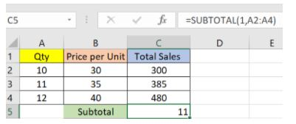

Fig: Subtotal function in Excel

In the example above, we have performed the subtotal calculation on cells ranging from A2 to A4. As you can see, the function used is

SUBTOTAL =SUBTOTAL(1, A2: A4)

In the subtotal list “1” refers to average. Hence, the above function will give the average of A2: A4 and the answer to it is 11, which is stored in C5. Similarly,

“=SUBTOTAL(4, A2: A4)”

This selects the cell with the maximum value from A2 to A4, which is 12. Incorporating “4” in the function provides the maximum result.

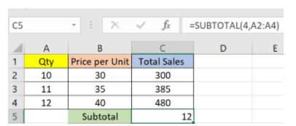

Fig: Count function in Excel

### **5. MODULUS**

The MOD() function works on returning the remainder when a particular number is divided by a divisor. Let’s now have a look at the examples below for better understanding.

* In the first example, we have divided 10 by 3. The remainder is calculated using the function

        MODULUS =MOD(A2,3)

* The result is stored in B2. We can also directly type “=MOD(10,3)” as it will give the same answer.

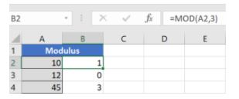

Fig: Modulus function in Excel

* Similarly, here, we have divided 12 by 4. The remainder is 0 is, which is stored in B3.

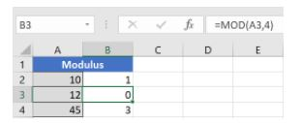

Fig: Modulus function in Excel

### **6. POWER**

The function “Power()” returns the result of a number raised to a certain power. Let’s have a look at the examples shown below:

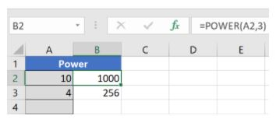

Fig: Power function in Excel

As you can see above, to find the power of 10 stored in A2 raised to 3, we have to type:

Power =POWER (A2,3)

This is how power function works in Excel.

### **7. CEILING**

Next, we have the ceiling function. The CEILING() function rounds a number up to its nearest multiple of significance.

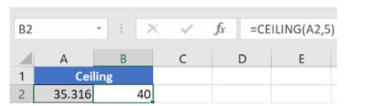

Fig: Ceiling function in Excel

The nearest highest multiple of 5 for 35.316 is 40.

### **8. FLOOR**

Contrary to the Ceiling function, the floor function rounds a number down to the nearest multiple of significance.

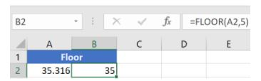

Fig: Floor function in Excel

The nearest lowest multiple of 5 for 35.316 is 35.

### **9. CONCATENATE**

This function merges or joins several text strings into one text string. Given below are the different ways to perform this function.

* In this example, we have operated with the syntax:

  CONCATENATE  =CONCATENATE(A25, " ", B25)

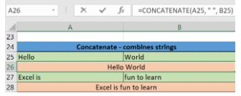

Fig: Concatenate function in Excel

* In this example, we have operated with the syntax:

        "=CONCATENATE(A27&" "&B27)"

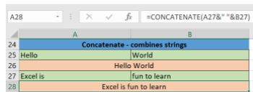

Fig: Concatenate function in Excel

Those were the two ways to implement the concatenation operation in Excel.

### **10. LEN**

The function LEN() returns the total number of characters in a string. So, it will count the overall characters, including spaces and special characters. Given below is an example of the Len function.

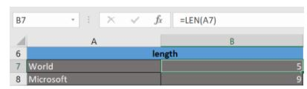

Fig: Len function in Excel

Let’s now move onto the next Excel function on our list of this article.

### **11. REPLACE**

As the name suggests, the REPLACE() function works on replacing the part of a text string with a different text string.

The syntax is “=REPLACE(old_text, start_num, num_chars, new_text)”. Here, start_num refers to the index position you want to start replacing the characters with. Next, num_chars indicate the number of characters you want to replace.

Let’s have a look at the ways we can use this function.

* Here, we are replacing A101 with B101 by typing

      REPLACE =REPLACE(A15,1,1,"B")

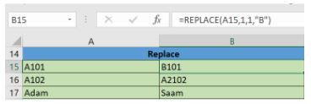

Fig: Replace function in Excel

* Next, we are replacing A102 with A2102 by typing:

        “=REPLACE(A16,1,1, "A2")”

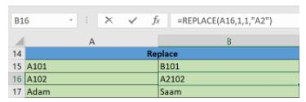

Fig: Replace function in Excel

* Finally, we are replacing Adam with Saam by typing:

        “=REPLACE(A17,1,2, "Sa")”

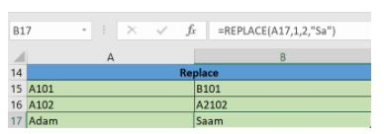

Fig: Replace function in Excel

Let’s now move to our next function. 

### **12. SUBSTITUTE**

The SUBSTITUTE() function replaces the existing text with a new text in a text string.

The syntax is “=SUBSTITUTE(text, old_text, new_text, [instance_num])”.

Here, [instance_num] refers to the index position of the present texts more than once.

Given below are a few examples of this function:

* Here, we are substituting “I like” with “He likes” by typing:

        “=SUBSTITUTE(A20, "I like","He likes")”

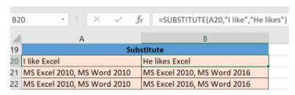

Fig: Substitute function in Excel

* Next, we are substituting the second 2010 that occurs in the original text in cell A21 with 2016 by typing “=SUBSTITUTE(A21,2010, 2016,2)”.

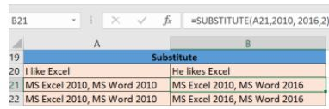

Fig: Substitute function in Excel

* Now, we are replacing both the 2010s in the original text with 2016 by typing “=SUBSTITUTE(A22,2010,2016)”.

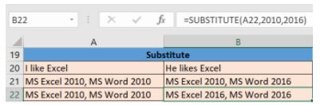

Fig: Substitute function in Excel

That was all about the substitute function, let’s now move on to our next function.

### **13. LEFT, RIGHT, MID**

The LEFT() function gives the number of characters from the start of a text string. Meanwhile, the MID() function returns the characters from the middle of a text string, given a starting position and length. Finally, the right() function returns the number of characters from the end of a text string.

Let’s understand these functions with a few examples.

* In the example below, we use the function left to obtain the leftmost word on the sentence in cell A5.

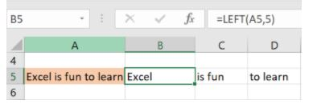

Fig: Left function in Excel

Shown below is an example using the mid function.

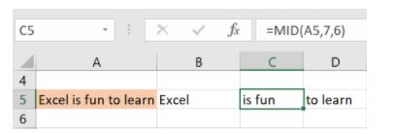

Fig: Mid function in Excel

* Here, we have an example of the right function.

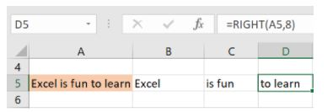

Fig: Right function in Excel

### **14. UPPER, LOWER, PROPER**

The UPPER() function converts any text string to uppercase. In contrast, the LOWER() function converts any text string to lowercase. The PROPER() function converts any text string to proper case, i.e., the first letter in each word will be in uppercase, and all the other will be in lowercase.

Let’s understand this better with the following examples:

* Here, we have converted the text in A6 to a full uppercase one in A7.

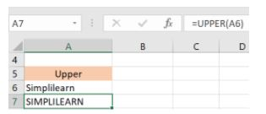

Fig: Upper function in Excel

* Now, we have converted the text in A6 to a full lowercase one, as seen in A7.

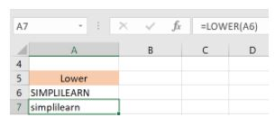

Fig: Lower function in Excel

* Finally, we have converted the improper text in A6 to a clean and proper format in A7.

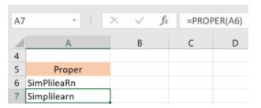

Fig: Proper function in Excel

Now, let us hop on to exploring some date and time functions in Excel.

### **15. NOW()**

The NOW() function in Excel gives the current system date and time.

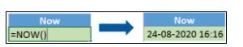

Fig: Now function in Excel

The result of the NOW() function will change based on your system date and time.

### **16. TODAY()**

The TODAY() function in Excel provides the current system date.

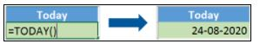

Fig: Today function in Excel

The function DAY() is used to return the day of the month. It will be a number between 1 to 31. 1 is the first day of the month, 31 is the last day of the month.

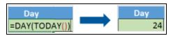

Fig: Day function in Excel

The MONTH() function returns the month, a number from 1 to 12, where 1 is January and 12 is December.

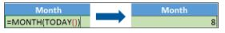

 Fig: Month function in Excel

The YEAR() function, as the name suggests, returns the year from a date value.

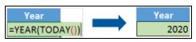

Fig: Year function in Excel

### **17. TIME()**

The TIME() function converts hours, minutes, seconds given as numbers to an Excel serial number, formatted with a time format.

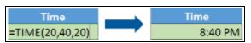

Fig: Time function in Excel

### **18. HOUR, MINUTE, SECOND**

The HOUR() function generates the hour from a time value as a number from 0 to 23. Here, 0 means 12 AM and 23 is 11 PM.

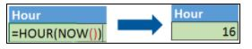

Fig: Hour function in Excel

The function MINUTE(), returns the minute from a time value as a number from 0 to 59.

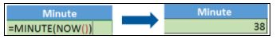

Fig: Minute function in Excel

The SECOND() function returns the second from a time value as a number from 0 to 59.

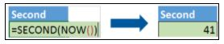

Fig: Second function in Excel

### **19. DATEDIF**

The DATEDIF() function provides the difference between two dates in terms of years, months, or days.

Below is an example of a DATEDIF function where we calculate the current age of a person based on two given dates, the date of birth and today’s date.

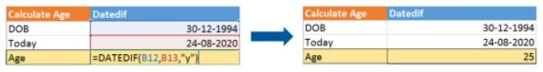

Fig: Datedif function in Excel

Now, let’s skin through a few critical advanced functions in Excel that are popularly used to analyze data and create reports.

### **20. VLOOKUP**

Next up in this article is the [VLOOKUP() function](https://www.simplilearn.com/tutorials/excel-tutorial/vlookup-in-excel). This stands for the vertical lookup that is responsible for looking for a particular value in the leftmost column of a table. It then returns a value in the same row from a column you specify.

Below are the arguments for the VLOOKUP function:

lookup_value - This is the value that you have to look for in the first column of a table.

table - This indicates the table from which the value is retrieved.

col_index - The column in the table from the value is to be retrieved.

range_lookup - [optional] TRUE = approximate match (default). FALSE = exact match.

We will use the below table to learn how the VLOOKUP function works.

If you wanted to find the department to which Stuart belongs, you could use the VLOOKUP function as shown below:

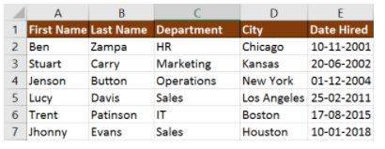

Fig: Vlookup function in Excel

Here, A11 cell has the lookup value, A2: E7 is the table array, 3 is the column index number with information about departments, and 0 is the range lookup.

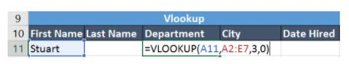

If you hit enter, it will return “Marketing”, indicating that Stuart is from the marketing department.

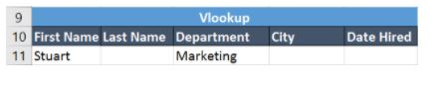

### **21. HLOOKUP**

Similar to VLOOKUP, we have another function called [HLOOKUP()](https://www.simplilearn.com/tutorials/excel-tutorial/excel-h-lookup) or horizontal lookup. The function HLOOKUP looks for a value in the top row of a table or array of benefits. It gives the value in the same column from a row you specify.

Below are the arguments for the HLOOKUP function:

lookup_value - This indicates the value to lookup.

table - This is the table from which you have to retrieve data.

row_index - This is the row number from which to retrieve data.

range_lookup - [optional] This is a boolean to indicate an exact match or approximate match. The default value is TRUE, meaning an approximate match.

Given the below table, let’s see how you can find the city of Jenson using HLOOKUP.

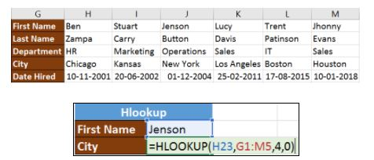

                                                     Fig: Hlookup function in Excel

Here, H23 has the lookup value, i.e., Jenson, G1:M5 is the table array, 4 is the row index number, 0 is for an approximate match.

Once you hit enter, it will return “New York”.

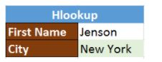

Our Data Analyst Master's Program will help you learn analytics tools and techniques to become a Data Analyst expert! It's the pefect course for you to jumpstart your career. Enroll now!

### **22. IF Formula**

The [IF() function](https://www.simplilearn.com/tutorials/excel-tutorial/excel-if-function) checks a given condition and returns a particular value if it is TRUE. It will return another value if the condition is FALSE.

In the below example, we want to check if the value in cell A2 is greater than 5. If it’s greater than 5, the function will return “Yes 4 is greater”, else it will return “No”.

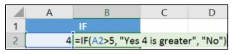

                     Fig: If function in Excel

In this case, it will return ‘No’ since 4 is not greater than 5.

‘IFERROR’ is another function that is popularly used. This function returns a value if an expression evaluates to an error, or else it will return the value of the expression.

Suppose you want to divide 10 by 0. This is an invalid expression, as you can’t divide a number by zero. It will result in an error.

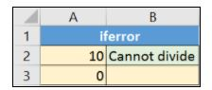

The above function will return “Cannot divide”.

### **23. INDEX-MATCH**

The INDEX-MATCH function is used to return a value in a column to the left. With VLOOKUP, you're stuck returning an appraisal from a column to the right. Another reason to use index-match instead of VLOOKUP is that VLOOKUP needs more processing power from Excel. This is because it needs to evaluate the entire table array which you've selected. With INDEX-MATCH, Excel only has to consider the lookup column and the return column.

Using the below table, let’s see how you can find the city where Jenson resides.

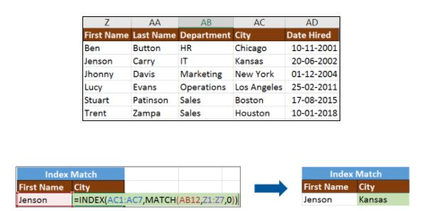

                                                       Fig: Index-Match function in Excel

Now, let’s find the department of Zampa.



### **24. COUNTIF**

The function COUNTIF() is used to count the total number of cells within a range that meet the given condition.

Below is a coronavirus sample dataset with information regarding the coronavirus cases and deaths in each country and region.

Let’s find the number of times Afghanistan is present in the table.





Fig: Countif function in Excel

The COUNTIFS function counts the number of cells specified by a given set of conditions.

If you want to count the number of days in which the cases in India have been greater than 100. Here is how you can use the COUNTIFS function.



### **25. SUMIF**

The SUMIF() function adds the cells specified by a given condition or criteria.

Below is the coronavirus dataset using which we will find the total number of cases in India till 3rd Jun 2020. (Our dataset has information from 31st Dec 2020 to 3rd Jun 2020).





 Fig: Sumif function in Excel

The SUMIFS() function adds the cells specified by a given set of conditions or criteria.

### **26. Goal Seek**

Goal Seek is a function in-built in Advanced Excel Functions that allows you to get the desired output by changing the assumptions. The process is dependent on the trial and error method to achieve the desired result.

Let’s look at an example to understand it better.

#### **Example**

In this example, we aim to find what will be the rate of interest if the person wants to pay

$5000 per month to settle the loan amount.

PMT function is used when you want to calculate the monthly payment you need to pay to settle the loan amount.

Let’s go through this problem in steps to see how we can calculate the interest rate that will settle a loan of $400,000 by $5,000 a month payment.

* PMT formula should now be entered in the cell that is the Payment cell adjacent. Currently, there is no value in the rate of interest cell, Excel gives us the payment of $3,333.33 because it assumes the rate of interest to be 0%. Ignore it.

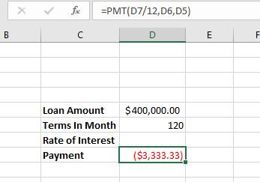

* Go to Data > What - If Analysis > Goal Seek



* Set the monthly payment to -5,000. The deduction in amount signifies the negative value.  
    
  Set rate of interest as the changing cell.

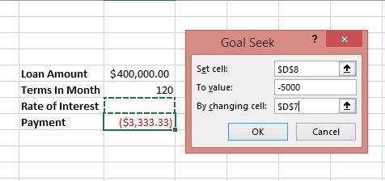

* Click OK. You will see the goal seek function automatically gives the interest rate that is required to pay the loan amount.

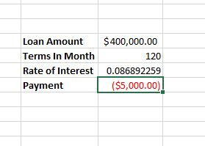

Go to Home > Number and change the [value to Percentage](https://www.simplilearn.com/tutorials/excel-tutorial/calculate-percentage-in-excel).

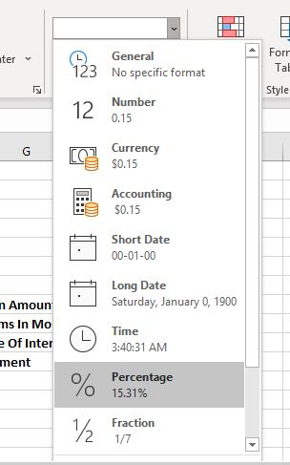

Your outcome will look like below:

### **27. What-If Analysis with Solver**

[What-If Analysis](https://www.simplilearn.com/tutorials/excel-tutorial/excel-what-if-analysis) is the method of changing the values to try out different scenarios for formulas in Advanced excel.

Several different sets of values can be used in one or multiple of these Advanced excel formulas to explore the different results.

A solver is ideal for what-if analysis. It is an add-in [program in Microsoft](https://support.microsoft.com/en-us/office/define-and-solve-a-problem-by-using-solver-5d1a388f-079d-43ac-a7eb-f63e45925040#:~:text=Solver%20is%20a%20Microsoft%20Excel,formula%20cells%20on%20a%20worksheet.) Excel and is helpful on many levels. The feature can be used to identify an optimal value for a formula in the cell known as the objective cell. Some constraints or limits are however applicable on other formula cell values on a [worksheet.](https://www.simplilearn.com/tutorials/excel-tutorial/excel-worksheet)

Solver works with decision variables which are a group of cells used in computing the formulas in the objective and constraint cells. The solver adjusts the value of decision variable cells to work on the limits on constraint cells. This process aids in determining the desired result for the objective cell.

Also Read: [The Best Guide to Build an Excel Dashboard](https://www.simplilearn.com/tutorials/excel-tutorial/excel-dashboard)

#### **Activating Solver Add-in**

* On the File tab, click Options.
* Go to Add-ins, select Solver Add-in, and click on the Go button.

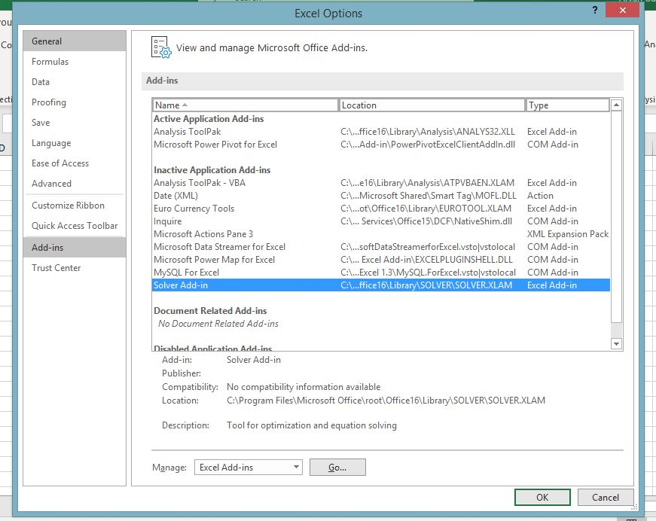

* Check Solver Add-in and click OK.

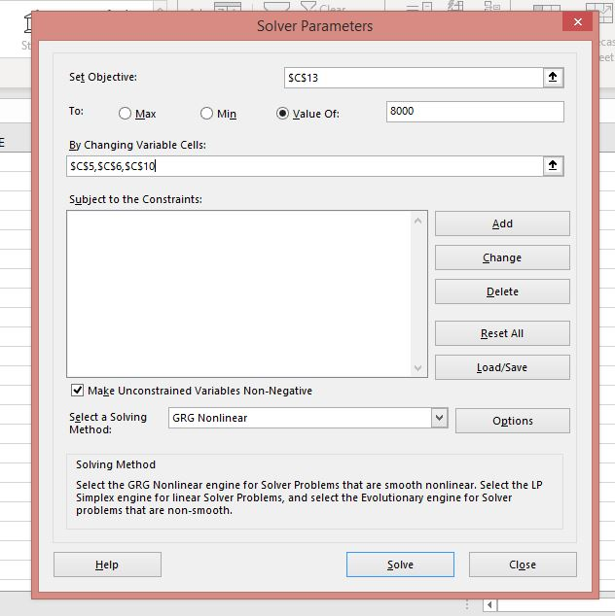

* In the Data tab, in the Analyze group, you can see the Solver option is added.

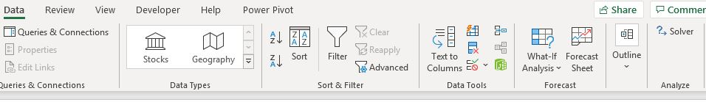

#### **How to Use Solver in Excel**

In this example, we will try to find the solution for a simple optimization problem.

Problem: Suppose you are the business owner and you want your income to be $8000.

Goal: Calculate the units to be sold and price per unit to achieve the target.

For example, we have created the following model:

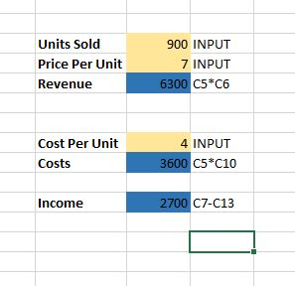

* On the Data tab, in the Analysis group, click the Solver button.
* In the set objective, select the income cell and set its value to $8000.
* To Change the variable cell, select the C5, C6, and C10 cells.



* Click Solve.

Your data model will change according to the conditions.

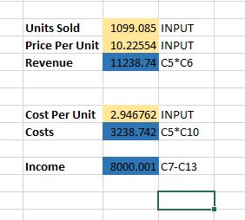

### **28. If-Else**

[IF function](https://www.simplilearn.com/tutorials/excel-tutorial/excel-if-function) is used to test the condition and return a value if the condition is indeed true and a predetermined different value if it turns out to be false.

If-Else =IF(test, true result, false result)

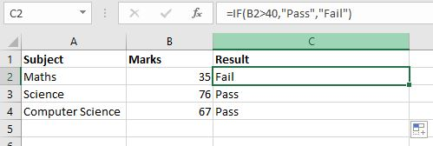

### **29. If-Error**

The Excel IFERROR function returns an alternative result when a formula generates an error and an expected result when no error is detected.

If-Error =IFERROR (value, value_if_error)

For example, Excel returns a divide by zero error when a[formula](https://www.simplilearn.com/tutorials/excel-tutorial/excel-formulas) tries to divide a number by 0.

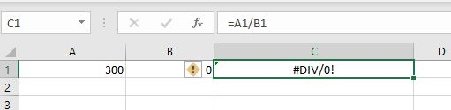

By using the IFERROR function, you can add a message if the formula evaluates to an error.

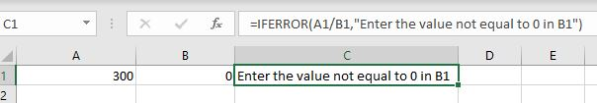

### **30. Index and Match**

This is an Advanced Excel function. MATCH function is designed to return the position of a value in a specified range, while the INDEX function returns a specific value present in a uni-dimensional range.

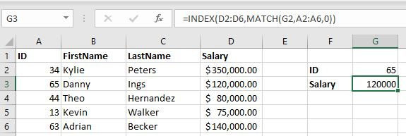

The MATCH function returns the position of the ID you are looking for. The INDEX function will return the value of the salary corresponding to the position.

### **31. Offset Function**

The OFFSET function returns a reference to a range of cells  that is a specified number of rows and columns from a cell or range of cells.

Offset Function =OFFSET(reference, rows, cols, [height], [width])

Example:

Consider the following data:

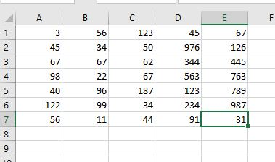

 To reference C4 starting at A1,  reference is A1, rows is 3 and cols is 2:

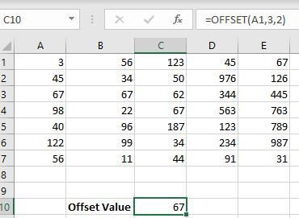



### **SUM Function With OFFSET**

In this example we have a monthly sales data of two years. The goal is to find the sum of sales for a specific month.

The OFFSET function returns a 1x2 range, 8 rows below cell A2, and 1 column right of cell A2. The SUM function then calculates the sum of this range.



## Choose the Right Program

Looking to build a career in the exciting field of data analytics? Our Data Analytics courses are designed to provide you with the skills and knowledge you need to excel in this rapidly growing industry. Our expert instructors will guide you through hands-on projects, real-world scenarios, and case studies, giving you the practical experience you need to succeed. With our courses, you'll learn to analyze data, create insightful reports, and make data-driven decisions that can help drive business success.

|  |  |  |  |
| --- | --- | --- | --- |
| **Program Name** | [Data Analyst](https://www.simplilearn.com/data-analyst-masters-certification-training-course?source=GhPreviewCourseTable) | [Post Graduate Program In Data Analytics](https://www.simplilearn.com/pgp-data-analytics-certification-training-course?source=GhPreviewCourseTable) | [Data Analytics Bootcamp](https://www.simplilearn.com/data-science-bootcamp?source=GhPreviewCourseTable) |
| Geo | All Geos | All Geos | US |
| University | Simplilearn | Purdue | Caltech |
| Course Duration | 11 Months | 8 Months | 6 Months |
| Coding Experience Required | No | Basic | No |
| Skills You Will Learn | 10+ skills including Python, MySQL, Tableau, NumPy and more | 10+ skills including Data Analytics, Statistical Analysis using Excel, Data Analysis Python and R, and more | 8+ Data Visualization with Tableau, Linear and Logistic Regression, Data Manipulation and more |
| Additional Benefits | Applied Learning via Capstone and 20+ industry-relevant Data Analytics projects | Purdue Alumni Association Membership Free IIMJobs Pro-Membership of 6 months Resume Building Assistance | Access to Integrated Practical Labs Caltech CTME Circle Membership |
| Cost | $$ | $$$$ | $$$$ |
|  | [Explore Program](https://www.simplilearn.com/data-analyst-masters-certification-training-course?source=GhPreviewCourseTable) | [Explore Program](https://www.simplilearn.com/pgp-data-analytics-certification-training-course?source=GhPreviewCourseTable) | [Explore Program](https://www.simplilearn.com/data-science-bootcamp?source=GhPreviewCourseTable) |

## Conclusion

Excel is a really powerful spreadsheet application for data analysis and reporting. After reading this article, you would have learned the important Excel formulas and functions that will help you perform your tasks better and faster. We looked at numeric, text, data-time, and advanced Excel formulas and functions. Needless to say, Excel knowledge goes a long way in shaping many careers.

Looking to advance your career in Data Science or Business Analytics? Simplilearn's [Caltech Post Graduate Program in Data Science](https://www.simplilearn.com/post-graduate-program-data-science?source=GhPreviewCoursepages) and [Business Analyst](https://www.simplilearn.com/business-analyst-certification-training-course?source=GhPreviewCoursepages) can help you achieve your goals! These comprehensive programs are designed to provide you with the skills and knowledge needed to excel in the field. Led by industry experts, the courses offer hands-on training, real-world projects, and personalized mentorship. Plus, upon completion, you'll receive a prestigious certification from one of the world's top universities. Don't wait, enroll now and take your career to the next level!

Do you have any questions related to this article on Excel Formulas? If yes, then please let us know in the comments section of the article. Our team of experts will help you solve your queries right away.

To kick-start your [fruitful career in Excel](https://www.simplilearn.com/role-of-microsoft-excel-certification-in-your-career-rar270-article), please click on the following link: [Business Analytics with Excel](https://www.simplilearn.com/big-data-and-analytics/business-analytics-certification-training?source=GhPreviewCoursepages).

## FAQs

### **1. What are the basic formulas in Excel?**

Basic formulas in Excel include arithmetic operations like addition, subtraction, multiplication, and division—for example, SUM, AVERAGE, COUNT, and PRODUCT.

### **2. What is MS Excel formulas and functions?**

MS Excel formulas and functions are expressions used to perform calculations or manipulate data in Excel. Formulas start with an equal sign (=) and can contain functions, mathematical operations, cell references, and constants.

### **3. How to write a formula in Excel?**

To write a formula in Excel, start with an equal sign (=), followed by the formula expression. For example, to add two numbers in cells A1 and B1, write "=A1+B1" in another cell.

### **4. What are basic Excel skills?**

Basic Excel skills include:

* Entering data.
* Formatting cells.
* Using basic formulas and functions.
* Creating simple charts.
* Sorting and filtering data.
* Understanding cell references.

### **5. What is VLOOKUP in Excel?**

VLOOKUP is a function in Excel used to search for a value in the first column of a table range and return a related value from a specified column. It's commonly used for data lookup and retrieval.

### **6. What is a formula in Excel?**

An Excel formula is a mathematical expression that works with values in a specific range of cells. These formulas yield a result, even if it's an error. They empower you to carry out addition, subtraction, multiplication, and division calculations within Excel.

### **7. What are the 5 important formulas in Excel?**

Some important Excel formulas include:

1. SUM: The SUM formula adds the values in a range of cells.
2. AVERAGE: The AVERAGE formula averages the values in a range of cells.
3. COUNT: The COUNT formula calculates the quantity of cells that hold numeric values within a designated range of cells.
4. IF: The IF formula assesses a condition and provides a specific output if the condition is true, or an alternative output if the condition is false.
5. VLOOKUP: The VLOOKUP formula searches for a value in a table and returns the corresponding value from another column in the table.